**MY ANDRIOD SUMMARY**

**1.**

**INSTALLATION:**

**2.**

**EDITOR PARTS AND FUNCTION:**

1. 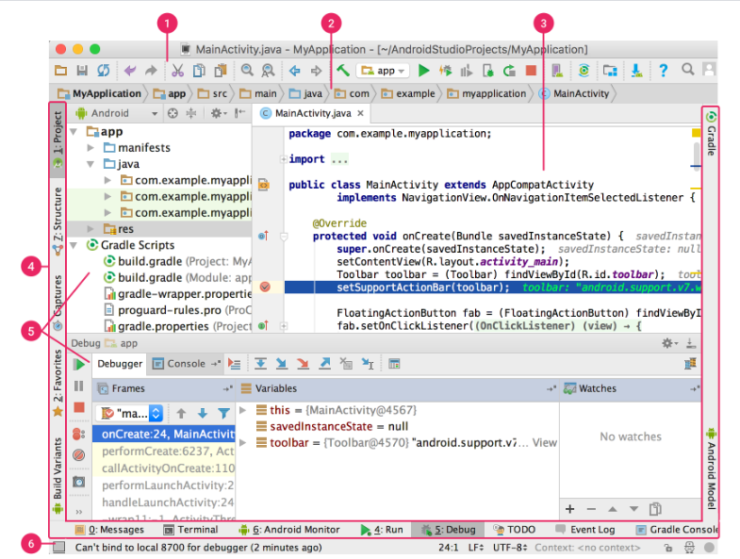
2. **Label 1** is the **toolbar**. It let’s you to carry out a wide range of actions.
3. Label 2 is the nav bar.  helps you navigate through your project and open files for editing. It provides a more compact view of the structure visible in the **Project** window.
4. Label 3 is the editor window
5. .

**3.**

**DEVELOPER OPTION:**

**Developer options** lets you configure system behaviors that help you profile and debug your app performance. For example, you can **enable debugging over USB**, **capture a bug report**, **enable visual feedback for taps**, **flash window surfaces when they update**, **use the GPU for 2D graphics rendering**, **and more**.

In version of **Android 4.2** and **higher**, to enable developer options, tap the **Build Number** option **7 times**. Build Number can be found as below, depending on your Android version:

* **Android 9** (API level 28) and **higher**: **Settings > About Phone > Build Number**
* **Android 8.0.0** (API level 26) and **Android 8.1.0** (API level 26): **Settings > System > About Phone > Build Number**
* **Android 7.1** (API level 25) and **lower**: **Settings > About Phone > Build Number**

Before you can use the debugger and other tools, you need to enable USB debugging, which allows Android Studio and other SDK tools to recognize your device when connected via USB. To enable USB debugging, toggle the **USB debugging** option in the Developer Options menu. You can find your device developer option in one of the following locations, depending on your Android version:

* **Android 9** (API level 28) and **higher**: **Settings > System > Advanced > Developer Options > USB debugging**
* **Android 8.0.0** (API level 26) and **Android 8.1.0** (API level 26): **Settings > System > Developer Options > USB debugging**
* **Android 7.1** (API level 25) and **lower**: **Settings > Developer Options > USB debugging**